2022 Disability:IN Global Report

Introduction
This was a year of firsts for Disability:IN Global Initiatives – hybrid and virtual events were hosted around the world in collaboration with the Disability:IN Global Roundtable and its APAC, EMEA and LATAM Councils with nearly 600 corporate representatives.
- Global Roundtable is co-chaired by David Sneddon, Google, Ireland, and Manisha Mehrotra, Bloomberg, UK.
- The APAC Council is co-chaired by Jo Keiko Terasawa, Google, Australia, & Vani Seshadri, Accenture, India.
- The EMEA Council is co-chaired by Katie Ingle, Bank of America, UK, and Shweta Soni, Amazon, United Arab Emirates.
- The LATAM Council is co-chaired by Ezequiel Massa, SAP, Mexico.
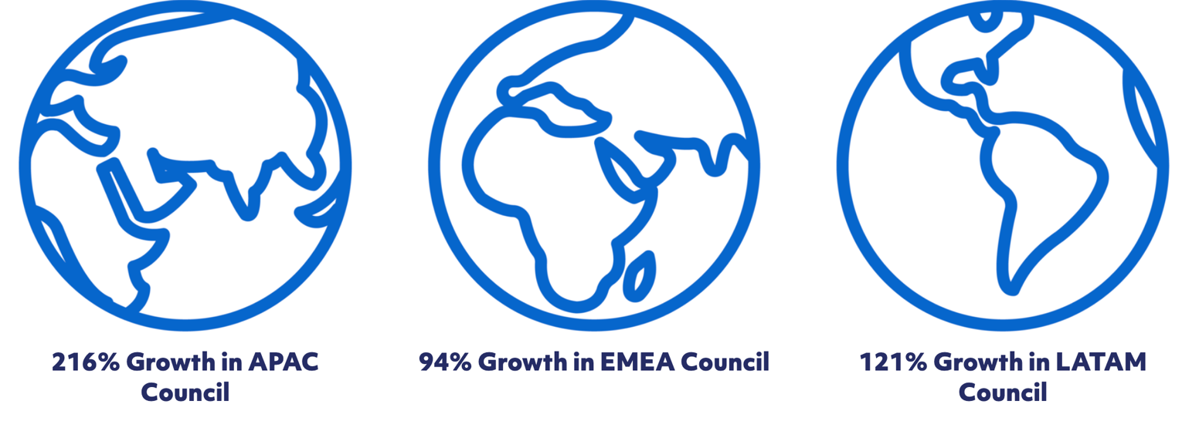
Disability:IN also established APAC, EMEA & LATAM Council subcommittees on Talent Acquisition and Business/Employee Resource Group (B/ERG) Leadership.
In addition, Disability:IN recruited and added to its international consulting team, Ching-Shiuan Jiang, formerly of the World Economic Fund and the United Nations, based in Taiwan to represent Disability:IN in the APAC Region; and Joan Bohan, formerly of Disney and KPMG, based in France to represent Disability:IN in the EMEA Region. Both have disability inclusion expertise. Disability:IN is continuing its search for a Latin America consultant.
The following report details Disability:IN’s 2022 global impact.

Building Inclusive and Equitable Businesses for All
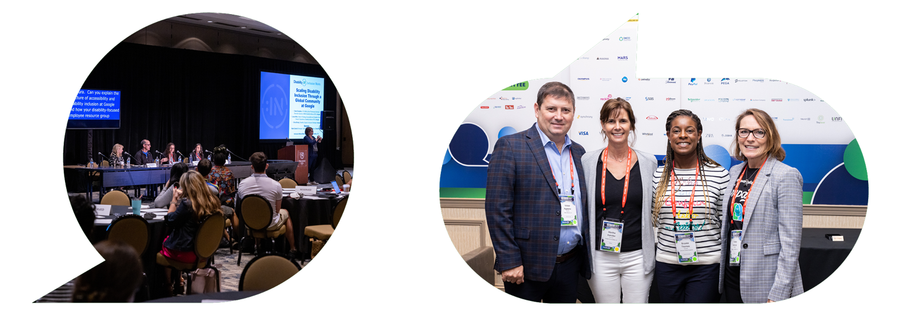

The 2022 Disability:IN Global Conference
- 4000+ Attendees
- 180+ Speakers
- 50 Countries Represented
- 5 Fortune 1000 CEOs
- 540 NextGen Leader Connections
- 380 Disability-Owned Business Connections
View the full overview of last year's conference here.
Join us for the 2023 Disability:IN Global Conference in Orlando, FL from July 10-13. Register here.

Certifying Disability Owned Businesses and the Global Disability Equality Index
In early 2022, we certified our first Disability-Owned Business Enterprise (DOBE) outside the U.S. This number has continued to grow. The Supplier Diversity program is the leading third-party certifier of disability-owned business enterprises (DOBE®s), including Veteran Disability-Owned Business Enterprises (V-DOBE®s) and Service-Disabled Veteran Disability-Owned Business Enterprises (SDV-DOBE®s). Learn more about certification or joining our International Certification Committee here.

The Global DEI came to fruition because many of our current partners expressed a desire to benchmark inclusion efforts around the world, both within their own brand as well as other industries. 40 companies registered for the first phase of the pilot in 2021, which included 30 countries. Top findings included: 1) a strong correlation between active ERGs and prioritization of accessibility, 2) A significant increase in the mental health benefits offered by multinational companies during the pandemic, and 3) one of the best indicators for success is inclusive leadership across multiple levels.
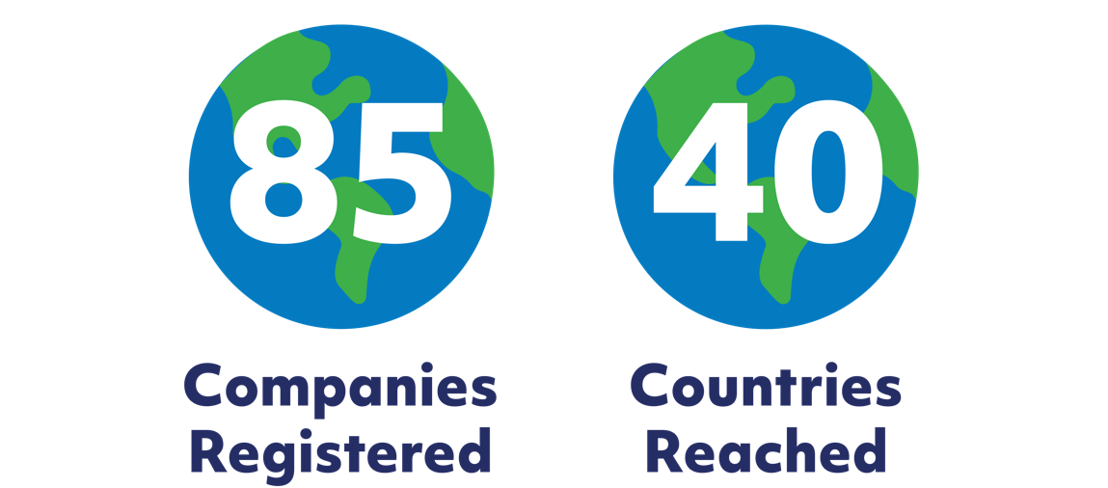

In 2022, we more than doubled GDEI registration to 85 companies. A report will follow which will include an analysis of our findings as well as next steps for scaling the Global DEI.
2023 GDEI Schedule
- July 18: Registration Opens. Register here.
- September 5: Questionnaire available to registrants
- December 16: Deadline for submission
- January 30: Scorecards/analysis sent to participants

For more information, contact Dorothy Garcia: Dorothy@disabilityin.org or visit our website.

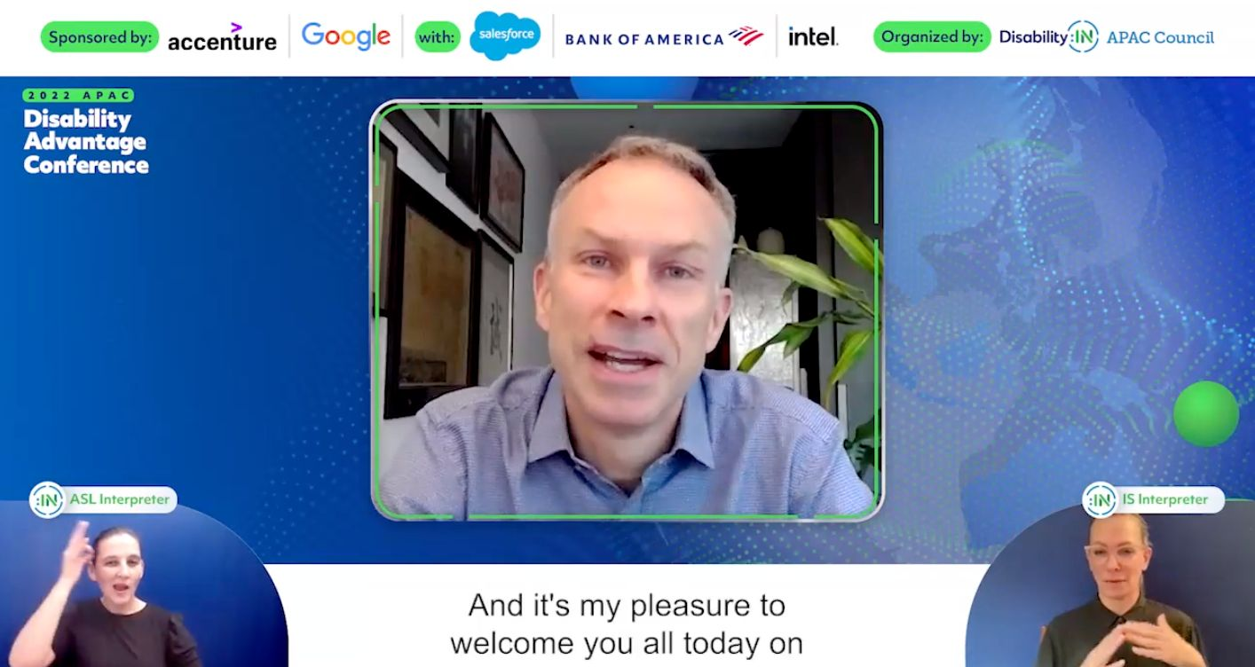

April 2022 | Asia Pacific (APAC) Disability Advantage Conference

Sponsored by Accenture & Google with Salesforce, Bank of America, and Intel
On April 20, 2022, Disability:IN hosted the first APAC Disability Advantage Conference. The event was well received across the world with 37 countries and 226 companies registered to attend.
Fourteen presentations focused on increasing disability inclusion in the APAC region. Forty speakers from 14 international companies shared their expertise on the panels.
Presentation topics included:

- Executive Commitment to Disability Advantage in APAC: Accenture, Google
- Facilitated Conversation on Disability Inclusion: Bank of America & Intel
- Creating a Global Corporate Disability Inclusive Culture: Dell, Google, EY
- Developing and Sustaining Business/Employee Resource Groups: Intel, Bank of America & Salesforce
- Digital Accessibility: Accenture, Intel, Google
- Adjustment/Accommodation Best Practices: Google, Intel
- Disability Inclusion & Etiquette: Accenture
- Effective Mental Wellness Programs: Accenture, Google
- Recruitment of Candidates with Disabilities: Bloomberg, AWS
- Global Self-ID Strategies: Bloomberg, Twitter
- The Evolution of the Americans with Disability Act (ADA): T-Mobile
- Accessibility Guidelines for Infrastructure Development: Bank of America, Accenture
- Neurodiversity in the Workplace: Accenture, SAP, EY
- Government Quotes for Employment of People with Disabilities: Google, IBM
A post-event evaluation survey was sent to registrants and presenters. Following are the results of the evaluation:

- 93% of registrants agreed the conference was “excellent to good.”
- 97% of registrants stated the topics discussed were “excellent to good.” Only 3% rated the topics average.
- On a scale of 1 (useless) to 5 (very useful), the meeting was ranked on average 4.61.
- 100% of the respondents confirmed the meeting was “beneficial to me and my company.”

The event garnered extensive social media attention. Following are links to posts created by Disability:IN Corporate Partners:

On LinkedIn:
- Sebastian Dennes
- Laura Grant
- Allison Heiliczer
- Laurie Henneborn
- Shoena Johnson
- Erica Brody
- Kim Bullock
- Gianfranco Casati
- Emma Olivier
- RampMyCity
- Vani Seshadri (Post #2)
- Natasha Shirazi
- David Sneddon
- Scott Beaumont
On Twitter:
- Sarah Hassaine
- Laurie Henneborn
On Instagram:
- Alfred Teoh
- Prateek Khandelwal
On Facebook:
- Rudy Guiao

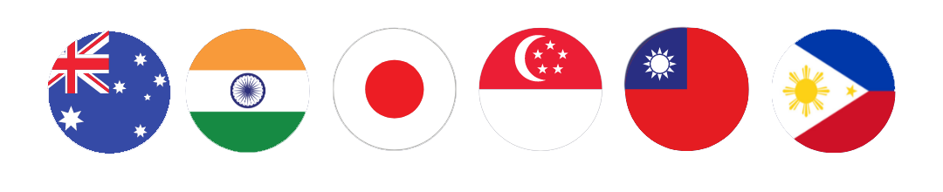

November 2022 | APAC Virtual Disability Recruiting Showcase

Sponsored by AWS & Google with Visa and Bloomberg
Disability:IN hosted on November 29, 2022, an APAC Virtual Disability Recruitment Showcase. This recruiting event was the first of its kind focused on recruitment of individuals with disabilities in six APAC countries: Australia, India, Japan, The Philippines, Singapore, and Taiwan.
The goal of the showcase was to connect companies operating in APAC to talent with disabilities who were college students, early & mid-career talent, and experienced candidates searching for internships, apprenticeships, or employment. A total of 15 companies participated with 37 recruiters.
Event sponsors were given the opportunity to present for longer periods of time, have dedicated Q&A immediately following their presentations, and were encouraged to select more than two countries in which to engage.
The event was fully accessible with simultaneous voice translation for Japan and Taiwan, local-language sign language for all six countries, and real-time captions in 30 languages available to all attendees.
The following outlines the country recruiting rooms and the companies that participated in each room:
- Australia: AWS, Google, Kraft Heinz, Pegasystems, ResMed, Zendesk (N=6)
- India: AWS, Google, Visa, Accenture, Citi, LinkedIn, Pegasystems, Qualcomm (N=8)
- Japan: AWS, Google, Visa, Bloomberg, Expedia Group (N=5)
- The Philippines: AWS, Google, Visa, Accenture, CBRE, Pfizer, Zendesk (N=7)
- Singapore: AWS, Google, Visa, Bloomberg, Expedia Group, LinkedIn, ResMed (N=7)
- Taiwan: AWS, Google, Citi, Qualcomm (N=4)
To source local talent with disabilities, the Disability:IN talent acquisition team and APAC regional consultant reached out to 88 local Non-Governmental Organizations, 45 local universities, and 8 local government agencies.
All sponsoring and participating companies received weekly reports, which included the number of registrants and their vetted Curricula Vita (CV).
A total of 596 candidates from 30 countries had the virtual opportunity to engage with the 37 recruiters from the 15 participating companies.
While candidates received access to all six countries’ recruiting rooms, they were encouraged to choose the countries in which they participated. The numeric breakdown of candidate interest was as follows:

- Australia 182 candidates
- India 338 candidates
- Japan 143 candidates
- The Philippines 144 candidates
- Singapore 170 candidates
- Taiwan 166 candidates

Following is the breakdown of candidate participation by country recruiting rooms:

- Australia 25% of registered candidates
- India 53% of registered candidates
- Japan 34% of registered candidates
- The Philippines 48% of registered candidates
- Singapore 37% of registered candidates
- Taiwan 57% of registered candidates

The job seekers were actively engaged in all rooms, evidenced by the number of questions asked: Australia 57, India 158, Japan 51, the Philippines 62, Singapore 80, and Taiwan 117.
APAC Virtual Disability Recruiting Showcase Results:
Of the 38 candidates who responded within 45 days of the event to the post-event evaluation:
- 95% agreed the APAC Recruitment Showcase experience was “excellent to good.”
- 80% of respondents confirmed the event “met their expectations,” 8% said it “did not meet their expectations” and 12% “offered no comment.”
- 97% gained a better “understanding of the interview process.”
- 95% gained a better “understanding of positions available.”
- 55% confirmed “they had been contacted by a company representative featured in the showcase to further discuss a position.”
- 10% had a scheduled interview resulting from the showcase.
- 21% of the candidates “accepted a position as a result of the showcase.”
- 2% of attendees “had been offered a position within 45 days of the showcase.”
The inaugural event was heralded on social media:
Twitter:
https://twitter.com/DisabilityIN/status/1598332696635314178
LinkedIn:
https://www.linkedin.com/feed/update/urn:li:activity:7004098489856983040
Facebook:
https://www.facebook.com/plugins/post.php?href=https%3A%2F%2Fwww.facebook.com%2FDisabilityIN%2Fposts%2Fpfbid02eotRA5nuecgPD1mGLbrUz9DJcvg6cxPk52jWzUu267ntCk4PeW4knozCvjvXEKDSl&
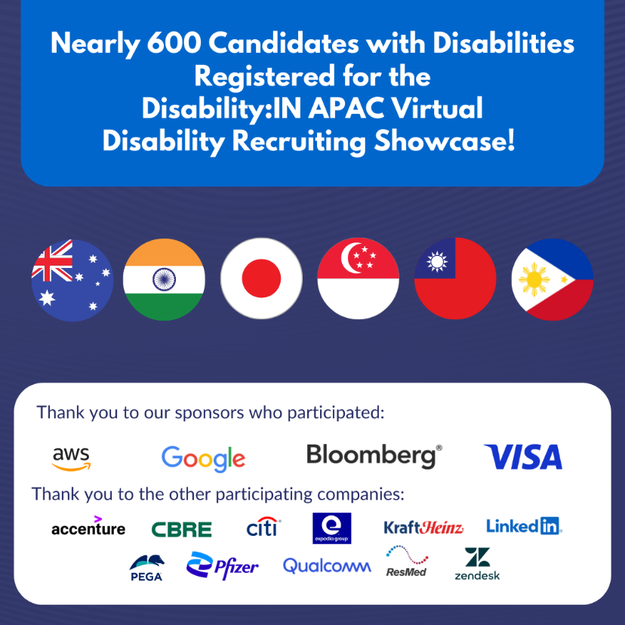

December 2022 | EMEA Disability Inclusion Summit

Hosted & Sponsored by Bank of America

With Google, Accenture, Bloomberg, & Uber
Seventeen speakers from eleven multi-national companies addressed the in-person and virtual audiences and shared their expertise and advice for advancing disability inclusion in EMEA workplaces. In addition to presenters from major corporations, Lord Shinkwin, a member of the United Kingdom House of Lords, addressed the audience.
More than 740 individuals from major corporations based in 48 countries registered to attend either in-person or virtually; 120 registrants attended in-person at the Bank of America Center in London.
The summit was composed of two keynote presentations and five topic specific presentations:
- Opening Keynotes: Bank of America, Google, Bloomberg, UK House of Lords
- Business/Employee Resource Groups as Strategic Business Partners – Making Disability Inclusion an ESG Priority: State Street, Accenture, Bank of America
- Journey to Physical & Digital Accessibility to Advance Inclusive Cultures at EMEA Companies: Uber, Intel, Pearson
- Effective Emergency Preparedness Planning: Addressing the Needs of EMEA Employees with Disabilities: Bloomberg
- Using Disability Owned Businesses in EMEA: Disability:IN
- Global Disability Benchmarking: Catalent, Solvay
- Closing Keynotes: Bank of America & Accenture
EMEA Disability Inclusion Summit Evaluation Results:
Of the attendees who responded to the post-event evaluation:
- 91% rated the EMEA Summit “excellent to good.”
- 100% of the respondents stated that the Summit was “helpful to them and their roles.”
- 91% said they gained a “better understanding of people with disabilities within their community.”
Following are links to publicly shared social posts:
- Google Accessibility Discovery Center in London
- Accenture's Accessibility Center in Dublin

- EMEA Summit Posts:

  - David Sneddon (Google)
  - Vanessa Curtis (CBRE)
  - Dynamo Academy
  - Philip Canale (BNY)
  - Naomi Johnson (Amazon)
  - Jess McNicholas
  - Paul Modley
  - Paula Milton
  - Paul Gallagher
  - Susan Mazrui
  - Lisa Hunter (Sony Europe)
  - Adriana Minniti (Pfizer)
  - Diane Hettinger
  - Jemile Mustafa (KBR)
  - Joan Fahey (Zendesk)

LATAM Council Webinar Series
In 2021, the LATAM Council began a two-year, five webinar series that concluded in 2022. The LATAM Council hosted two webinars in 2022.
The first webinar took place in April, in partnership with the EMEA Council, and was titled, What Do I Need to Know About Digital Accessibility. More than 280 corporate representatives from LATAM and EMEA registered to join the webinar from 29 countries. Jeff Wissel, Chief Accessibility Officer, Disability:IN shared tangible steps and explained how to adapt digital accessibility to diverse cultures around the world. Specific topics included:
- The proximity of disability.
- What is digital accessibility?
- What is accessibility, in general?
- Gaining senior leadership support.
In October 2022 the LATAM Council hosted the fifth and final webinar of the two-year series titled, Corporate Leadership for Disability Inclusion, moderated by Oz Mondejar, Disability:IN. Speakers from Accenture, Intel, and PwC Mexico shared best practices and tangible steps on “how-to” engage those in the C-Suite and other leadership positions to advance disability inclusion in LATAM workplaces.
From 19 countries a total of 354 corporate representatives registered to attend. An event evaluation was sent to all attendees. Of those who responded to the evaluation:
- 90% agreed the webinar was “excellent to good.”
- 81% confirmed “they gained a better understanding of disability inclusion at their company.”
- 95% agreed “the webinar enabled them to have a better understanding of disability inclusion in their local community.”

Conclusion
Business is the greatest platform for global advancement of disability inclusion, equity & equality.
Disability:IN is excited about continuing to work together to advance disability inclusion around the world through the work of its Global Roundtable and Councils in APAC, EMEA, and LATAM.

