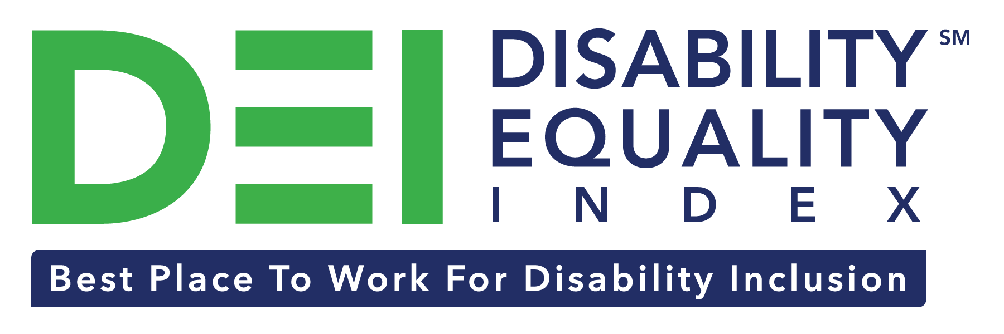

RESOURCE GUIDE
FOR TOP-SCORING COMPANIES – 80, 90, 100
Preface 1
How your Company will be Recognized 2
Digital Recognition 2
Press & Media 3
Virtual - Disability:IN Annual Conference on July 2020 3
Sharing Your Top Score with Various Stakeholders 3
Customers, Clients, Employees 3
Senior Leadership 4
Cross-Functional Teams 4
ESG/CSR stakeholders and investors 4
Marketing & Communications Resources 6
Messaging A Top Score 6
DEI Score Logos For Use 7
Sample Social Media Posts 7
What’s Next? Join IN! 8
Additional Guidance & Amplification Opportunities 9
FREE Disability Inclusion Resources 9
Scorecard Deep Dive 9
Disability:IN Inclusion Works – Unlimited Consulting Services 9
Registering for the 2021 DEI 9

Preface
Congratulations on earning a top score on the DEI! This is a testament to the culture of inclusion your company is building. This document guides cross-functional teams, including marketing and communications, finance and investment, senior leadership, and other departments.

Although your company has earned a top score, it doesn’t mean that the effort towards advancing inclusion for people with disabilities is complete. In order to help nudge all participating companies to do more, the bar is continually raising with the DEI, through updated existing questions weighting and/or additional questions added. Each time your company participates in the DEI, you are able to benchmark performance year over year, gaining concrete insight into areas of opportunity and success.

We encourage you to share your score with your employees, stakeholders, board of directors, senior leadership, customers, and suppliers. Once you’re ready to dive back in, we’re here to help meet you where you’re at and to continue building a culture of inclusion for all people.

Upcoming DEI Top Scoring Company Webinars:
- JUNE 16, 2-3 PM EDT: Register here
- JUNE 18, 2-3 PM EDT: Register here
Point of Contact information:
Becky Kekula, Disability Equality Index, Disability:IN | Becky@DisabilityIN.org
Elaine Kubik, Marketing & Communications, Disability:IN | Elaine@DisabilityIN.org

How your Company will be Recognized

Digital Recognition
On Wednesday, July 15th, Disability:IN and AAPD will make public announcements on all owned channels starting at 8:00am EDT. This includes social media, websites, and email campaigns.

Websites:
- Disability:IN: https://disabilityin.org/
- AAPD: https://www.aapd.com/

Twitter:
- @DisabilityIN: https://twitter.com/disabilityin
- @AAPD: https://twitter.com/AAPD
  - Recommended hashtags: #DEI #BestPlacetoWork
  - Additional hashtag for consideration: #AreYouIN
Facebook:
- Disability:IN: https://www.facebook.com/DisabilityIN
- AAPD: https://www.facebook.com/DisabilityPowered
  - Recommended hashtags: #DEI #BestPlacetoWork
LinkedIn:
- Disability:IN: https://www.linkedin.com/company/disabilityin
- AAPD: https://www.linkedin.com/company/american-association-of-people-with-disabilities

Instagram:
- Disability:IN: https://www.instagram.com/disabilityin

After announcing all top-scoring companies of the DEI, Disability:IN will then recognize each top-scoring company individually on social media, throughout the year.

Please alert and encourage your corporate communications teams to share any social media posts from Disability:IN and/or AAPD recognizing your company’s efforts. We’re more than happy to do the same for you, and amplify your company’s posts, if you tag us.

Press & Media
On Wednesday, July 15th at 8:00am EDT, Disability:IN will issue a press release over the Globe Newswire. The press release will simply list out top-scoring companies. See last year’s press release.

Virtual - Disability:IN Annual Conference on July 2020
On Wednesday, July 15th, your top-scoring DEI company will be recognized at the Disability:IN Annual Conference, Inclusion Awards Dinner.

There’s still time to register: www.conference.disabilityin.org. Please contact Becky (Becky@DisabilityIN.org) for more information.

Communicating Your Top Score with Various Stakeholders

Customers, Clients, Employees
Press/News Release
- Whirlpool Press Release: “Whirlpool Corporation Scores 100 Percent on 2019 Disability Equality Index”
- Walgreens Press Release: “Walgreens Earns Best Place to Work in 2019 Disability Equality Index”
- Ultimate Software Press Release: “Ultimate Software Named Top-Scoring Company on 2019 Disability Equality Index”

Website Spotlight
- Accenture Website: Inclusion & Diversity> Enabling Persons with Disabilities
- HP Website: Global Diversity & Inclusion
- Kaiser Permanente Website: Accolades & awards
Executive Letter
- Starbucks Executive Letter from Lucy Helm, EVP, general counsel and secretary, Law & Corporate Affairs and chair of the Starbucks Inclusion Council
- Grainger Chairman & CEO Letter, from D.G. Macpherson, introducing their 2018 CSR report

Cross-Functional Teams
Your scorecard provides insight into how well your company has advanced inclusion for each category. There are six (6) categories within the 2020 DEI benchmark. We recommend taking relevant sections of the scorecard and meeting with team leads to review opportunities for advancement.
  - Culture & Leadership = HR,
  - Enterprise-Wide Access = Technology, HR,
  - Employment Practices = HR
  - Community Engagement = CSR
  - Supplier Diversity = Supplier Diversity
  - Non-U.S. Operations = Supplier Diversity, International, HR

ESG/CSR stakeholders and investors
As a top-scoring company, your team may choose to communicate your top score with external stakeholders. Below are a few ways we have seen top-scoring companies communicate their scores:
- Corporate Social Responsibility Report: CVS 2019 CSR Report – Ratings, Rankings, Recognition
- Environmental, Social, Governance Report: Walmart 2019 ESG Report – Social Goals
- Sustainability Report: Whirlpool 2019 Report- Recognition
- Annual Shareholder Meetings: Doug McMillon’s remarks at Walmart’s 2019 Annual Shareholders’ Meeting
- Board of Directors/Investor meetings: Voya Financial 2018 quarterly investor presentation

Additional Information/Background:
In October 2018, an Accenture report documented that companies that embrace best practices for employing and supporting more persons with disabilities in their workforces have outperformed their peers. Top inclusive companies earned 28 percent higher revenue, double the net income and 30 percent higher economic profit margins than their peers.
Getting to Equal: The Disability Inclusion Advantage, report from Accenture, in partnership with Disability:IN and AAPD.

In May 2019, an investor group formed calling on companies they invest in to be inclusive to people with disabilities. A year later, the investor group on disability inclusion expands globally with 22 investors managing over $2.8 trillion in assets.

Recent milestones:
- September 2019: CT Treasurer Wooden Calls on Major Corporations to Adopt Disability Inclusion Practices and Reporting, sending direct letters to 20 of CT pension funds’ top holdings
- October 2019: NY State Comptroller DiNapoli sends third round of outreach letters to 46 CEOs urging more inclusive practices.
- November 2019: BlackRock American Association of People with Disabilities and Disability:IN facilitate forward-thinking dialogue on disability inclusion with investors and global inclusion leaders.
- December 2019: Ethisphere announced that it will collaborate with the American Association of People with Disabilities (AAPD) and Disability:IN to bring data, research and tools to the business community, with the goal of promoting disability inclusion in the workforce.
- January 2020: CEOs from Accenture, CVS Health, Intel, Microsoft, Voya Financial, and Walmart issue letter urging Fortune 1000 to participate in the Disability Equality Index
- January 2020: PRI Podcast with Fiona Reynolds, CEO, PRI and Ted Kennedy, Jr. “Why Disability Inclusion in the Workplace is an Investor Issue”
- February 15, 2020: PRI Webinar with Fiona Reynolds, CEO, PRI, Michael Frerichs, Illinois State Treasurer, and Ted Kennedy, Jr. “Disability Inclusion: a strategic ESG perspective for investors”
- February 2020: New York State Common Retirement Fund updates Environmental, Social & Governance Principles & Proxy Voting Guidelines (includes disability inclusion)
- March 10, 2020: Massachusetts PRIM Board Approves Treasurer Goldberg's Proposed Proxy Voting Guidelines Increasing Board Diversity, Banning Guns at Work, and Prohibiting Discrimination Against People with Disabilities
- May 21, 2020: Global Investor Group Representing $2.8 Trillion Call on Companies to be Inclusive to People with Disabilities

Senior Leadership
When communicating with senior leadership, it is helpful to highlight:
- Why Disability Inclusion is Good for Business
  - Accenture Report “Getting to Equal: The Disability Inclusion Advantage”
  - Joint Investor Statement on Corporate Disability Inclusion. (22 signatories representing over $2.8 trillion in assets under management)
- Competitive Comparisons
  - Top-Scoring Companies list – does this include competitors? Potential clients?
  - CEOs who are IN – CEO-to-CEO Letter on Disability Inclusion from 6 CEOs (Accenture, CVS Health, Intel, Microsoft, Voya Financial and Walmart)
- Your ASK – how can you advance inclusion?
- Internal support – cross functional teams, senior leadership, etc.
- External support – register for 2021 DEI, further engagement with Disability:IN
- Multi-faceted sign-on Campaign – Are You IN?

Marketing & Communications Resources

Messaging A Top Score
100% on the DEI does not constitute as a “perfect score”. There is always room to advance disability inclusion! Please avoid using the term “perfect” in any of your DEI top-score promotional materials. “Top-score” or “top-scorer” are the preferred terms.

Employers that have earned a 100 percent on the DEI have satisfied the criteria for that year and are recognized as a "Best Place to Work for Disability Inclusion." A score of 100 on the DEI simply means that a company adheres to many of the numerous leading disability inclusion practices featured in the DEI. It does not convey perfection.

These criteria have been created to encourage employers to participate in the index year after year and to advance the best practices that should be expected of all large employers. The criteria have always been intended to evolve as more employers adopt existing criteria and new best practices emerge.

Other Messaging Requirements:
- Always include that the DEI is a joint initiative of the American Association of People with Disabilities (AAPD) and Disability:IN.
- Include registered mark “®” in superscript for first reference of the DEI. When referencing the DEI, include hyperlink to http://www.disabilityequalityindex.org website.
Boilerplate/About the DEI:
The Disability Equality Index® (DEI) is a national, transparent benchmarking tool that offers businesses an opportunity to self-report their disability inclusion policies and practices. It was developed by two national leaders, American Association of People with Disabilities (AAPD) and Disability:IN, in consultation with the appointed DEI Advisory Committee, a diverse group of experts in business, policy, and disability advocacy.

Messaging channels your company can leverage (examples + supporting material in this document):
- Company website
- Career and/or diversity & inclusion webpage
- Social media accounts
- Email signature line
- Press Release boilerplate
- Recruiting materials
- Employee Resource Group (ERG) materials
- Self-Disclosure Campaigns
- Company-wide town halls

DEI Score Logos For Use
2020 DEI top-scoring companies receive the benefit of, and are authorized to use, the 2020 DEI Best Places to Work™ logo. This logo has been provided to you. Please contact Becky Kekula if you need a duplicate copy.

Brand Logo Guidelines
- Do not combine the logo with any other logo, text, or graphics.
- Do not place the logo within a shape or background that consists of textures, graphics, or color that may reduce visibility.
- Never alter the logo artwork file by creating a new version or changing the size, color, or proportion.
- Do not use the logo as part of a sentence, headline, or title.

Sample Social Media Posts
Feel free to tweak to align with your company’s brand and voice.
- Proud to be named one of the #DEI #BestPlacetoWork for #DisabilityInclusion @DisabilityIN @AAPD
- (Company) is proud to have earned a XX% on #DEI for #DisabilityInclusion @DisabilityIN @AAPD
- Proud to be among the top-scorers for #DEI #DisabilityInclusion @DisabilityIN @AAPD
- Proud of (Company’s) top-score on @DisabilityIN and @AAPD #DEI for #DisabilityInclusion
- Honored to be a #BestPlaceToWork for #DisabilityInclusion on the #DEI.
- Proud of our #DisabilityInclusion efforts and the work we do for #PwD. @DisabilityIN @AAPD
- Disability inclusion drives #innovation. (Company) values all talent and we’re proud to have earned a top score on the Disability Equality Index!

Included Attachment: Social Media Graphic
- Download here a social media graphic your company can use on social media platforms.
- To place your company logo in the placeholder in the graphic, please open this graphic in a photo editing software/platform. You could use something simple like Microsoft Paint, or even the free version of https://www.canva.com.
- Once the graphic is opened in a photo editing platform, then you upload your company logo and arrange it to cover the text placeholder.

Social Media Accessibility
As companies post about their disability inclusion efforts, it’s a best practice to ensure those social media posts are accessible. For example, photos should have alt-text descriptions and videos include captions. We recommend reviewing the Federal Social Media Accessibility Toolkit Hackpad for additional guidance.

What’s Next? Show the World you’re IN
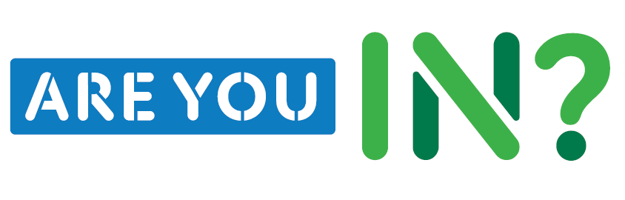
As a top-scoring company, you can use Disability:IN’s upcoming campaign “Are You IN?” as a vehicle to share your inclusion efforts. You will automatically receive the “INSIDER Toolkit”. Email Elaine@DisabilityIN.org for more information or to schedule a call.

Campaign Brief:
The Are You IN campaign (#AreYouIN) invites Companies, CEOs, Investors, and Business Professionals to join IN to advance disability inclusion. The campaign will be launched to the public on July 14, during the Opening Plenary of the Disability:IN Conference.

All Business Professionals who join IN will receive resources to start building a roadmap towards disability inclusion.

Opportunities to join IN (prior to launch; opportunities still available after launch!):
- CEO: If your CEO has already signed similar initiatives, they may be able to also join IN! CEOs that are in can sign the following CEO letter: https://disabilityin.org/disability-equality-index/ceo-to-ceo/.
Deadline for CEO to sign on to be shown at LAUNCH: June 30
NO Deadline for CEO sign-ons after campaign launch
- Investors: Any asset managing company or financial institution is also invited to join IN as an investor. Investors that are in sign the following Investor statement: https://disabilityin.org/what-we-do/disability-equality-index/investor-statement/
Deadline for Investors to sign on to be shown at LAUNCH: June 30
NO Deadline for Investor sign-on after campaign launch

- Business Professionals: Invite your ERGs, team members, and senior leadership to join IN. Anyone who signs up will receive relevant communications on how they can advance inclusion in their capacity.
Early invite available June 30 to be included at LAUNCH
Open to ALL after Launch!
INSIDER Toolkit Inventory
- Executive Leader Communication
- Customizable Collateral (Posters/Flyers)
- Social Media Content (Twitter header, social graphics, etc.)
- ERG/BRG Bundle: July 26-31 ADA Anniversary ‘Action Week’ Inclusion Daily Challenges

Additional Guidance & Amplification Opportunities

FREE Disability Inclusion Resources
As you review your scorecard, you may want to begin advancing inclusion in certain areas of business. The Disability:IN website, under “Resources”, has a variety of resources for teams to dive into, including “Roadmap to Mental Wellness”, “Disability Etiquette” and more.

Scorecard Deep Dive
Your DEI score came with data and insight on your scorecard. If you’d like a deep dive and learn more about how your company has earned a top-score, or what you can do to maintain or improve next year, please reach out to Becky Kekula.

Disability:IN Inclusion Works – Unlimited Consulting Services
Inclusion Works provides participating companies with unlimited, customized, virtual and onsite consulting provided by a team of disability inclusion experts. We help you create an inclusive culture while simultaneously developing a sustainable recruitment strategy.
Joining Inclusion Works also connects your company to a Community of Corporations with exclusive meetings and shared best and evolving practices. To date the community of corporations have hired over 50,000 people with disabilities and has grown to 49 participating companies. Learn more about Inclusion Works.

Registering for the 2021 DEI
Gain year over year benchmark insights and register for the 2021 DEI. Registration opens July 14, 2020 until January 31, 2021. Register at www.disabilityequalityindex.org/register.

