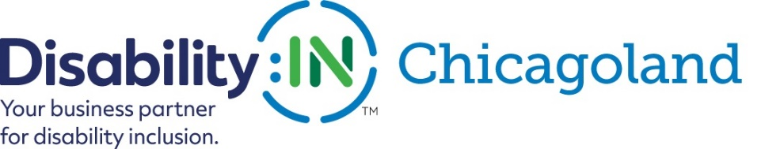

Maximizing the Disability Inclusion Advantage

Wednesday October 2, 2019
8:00-10:00 AM
Northern Trust
50 S. LaSalle
Chicago, IL 60603

Join Disability:IN Chicagoland for a breakfast session to learn more about how businesses across the country are utilizing disability inclusion to achieve a competitive advantage. Research recently released by Disability:IN, in partnership with Accenture and the American Association of People with Disabilities (AAPD), examined whether a positive correlation exists between a company’s disability inclusion efforts and its financial performance. Data indicates that companies who employ and support individuals with disabilities outperform their peers.
SPONSOR:

inQUEST Consulting CEO, Scott Hoesman, will conduct a fireside chat with Accenture’s Corporate Counsel and Chief Compliance Officer Chad Jerdee to discuss the report’s key findings and its potential impact on corporate America. Don’t miss this stimulating discussion and your chance to network with professionals from local companies who are prioritizing disability inclusion.
REGISTRATION AVAILABLE SOON:
For more information contact Laura Wilhelm - Laura@di-chi.org
