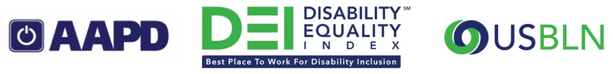
2018 Disability Equality Index® (DEI®) Best Places to Work™
The American Association of People with Disabilities and the US Business Leadership Network® are honored to recognize the following companies that scored an 80 or above on the 2018 DEI. The 2018 DEI was completed by 145 companies in 2018.
Note: The companies are listed in alphabetical order, by the company name as provided to AAPD and USBLN.
Companies that scored 100%
3M | Accenture | Aetna | AMC Theatres | Ameren Corporation
American Airlines | American Electric Power | Anthem, Inc. | Aramark | AT&T
BAE Systems, Inc. | Bank of America | Baylor Scott & White Health | Biogen | Blue Cross Blue Shield of Michigan
BMO Harris Bank | Boehringer Ingelheim USA | Booz Allen Hamilton | Boston Scientific | Brown-Forman Corporation
Capital One Financial Corporation | Cargill | Centene Corporation | Cigna | Comcast NBCUniversal
Corning | CVS Health | Dell Inc. | Deloitte | Delta Air Lines, Inc.
DTE Energy | DuPont | Express Scripts | EY | Facebook
Fidelity Investments | Financial Industry Regulatory Authority (FINRA) | Florida Blue | Freddie Mac | General Motors
GlaxoSmithKline plc | Goldman Sachs & Co. | Health Care Service Corporation | Hewlett Packard Enterprise | Highmark Health
HP Inc. | Huntington National Bank | Intel Corporation | JPMorgan Chase & Co. | Kaiser Permanente
KPMG | L’Oréal USA | Lincoln Financial Group | Lockheed Martin | ManpowerGroup
Mastercard | Mayo Clinic | Medtronic | Meijer | Merck
Microsoft | Northrop Grumman Corporation | Old National Bank | Pacific Gas & Electric | PNC Financial Services, Inc.
Proctor & Gamble | Prudential Financial | PwC | Qualcomm, Inc. | Southern Company
Spaulding Rehabilitation Network | Sprint Corporation | State Street Corporation | Synchrony | T-Mobile
TD Bank | The Boeing Company | The Dow Chemical Company | The Hartford Financial Services Group, Inc. | The Walt Disney Company
Thermo Fisher Scientific | Thomson Reuters | Travelers | Tufts Health Plan | U.S. Bank
United Airlines | Verizon | Walgreens | Walmart Inc. | Wells Fargo & Company
Whirlpool Corporation

Companies that scored 90%
AXA | Bristol-Myers Squibb Company | Cisco | DXC Technology | Johnson & Johnson
M&T Bank | MassMutual | McKesson Corporation | MetLife | Nielsen
Northern Trust | Northwestern Mutual | OppenheimerFunds, Inc. | PPL | Quest Diagnostics
Raytheon Company | Royal Caribbean Cruises Ltd. | Sodexo | Southern California Edison | Steptoe & Johnson LLP
Unilever U.S. | UPS | Voya Financial

Companies that scored 80%
Amazon.com | Choice Hotels | CSX Transportation, Inc. | Entergy | Ford Motor Company
Monsanto Company | Norfolk Southern Corporation | Southwest Airlines | USAA | United Technologies Corporation
Unum Group | W.W. Grainger

To learn more about the DEI, visit: https://www.disabilityequalityindex.org
AAPD. USBLN. All rights reserved.

