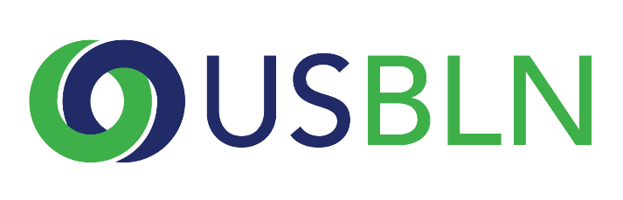
2018 USBLN® ANNUAL LEADERSHIP AWARDS
Marketplace Innovator of the Year Nomination

THE DEADLINE FOR NOMINATIONS IS
FRIDAY, JANUARY 12, 2018

The USBLN® 2018 Annual Leadership Awards "Marketplace Innovator of the Year” has two categories - one category for an external marketing or communications campaign that includes powerful and positive images of disability, and one category for developing products or customer service experiences that are designed to be used by people of all abilities. A company must be a member of the USBLN® to be considered for this award.
Please note that if your company is selected to receive this award, you will be asked to submit photos and/or videos to the USBLN for use in an introductory video that will be shown during the award presentation at the 2018 USBLN 21st Annual Conference & Expo. These visuals will need to be submitted 4 weeks after notification. Will you be able to do this? Yes __ No__

Please complete the nomination form in its entirety:
1. Organization Name:
2. Contact information of primary company representative to be notified:
Name
Title
Organization
Mailing Address
Phone
Email
Website
3. Contact information of a secondary company representative to contact:
Name
Title
Organization
Mailing Address
Phone
Cell Phone
Email

4. Contact information of person responsible for completing the nomination form:
Name
Title
Organization
Mailing Address
Phone
Email

5. Which category is this application for? (Note: if you are applying in both categories, please submit two separate nomination forms.)

External Marketing or Communications Campaign ___________
- Marketing and Communications examples include but are not limited to print advertising, social media campaigns, commercials, online videos, billboards, articles.

Product Design/ Customer Services or Experience Design ____________
- Product Design examples include but are not limited to products that are designed and marketed broadly to the general public but which intentionally employ universal design principles: e.g. shoes or clothing, voice-activated products, communication or technology innovations
- Customer Service or Experience Design examples include but are not limited to processes, services or experiences that are intentionally developed to enhance an inclusive and satisfying customer experience for individuals with disabilities: e.g., customer solutions desk, hospitality and travel industry accessibility services

6. Please provide an overview of the company including founding date, type of industry, mission statement, head quarter’s city and state, whether it is national or multi-national, number of employees in the U.S. and number of employers outside the U.S. (1,000 words or less)
7. Please present a narrative that provides the background, motivation, process, innovations, and results that your company experienced in the marketplace category you chose. (narrative only; please do not attach documents) (2,000 words or less) 70 points
8. Please provide links to the advertisements, communications, products, or service descriptions cited in your narrative. 20 points
9. Please provide any other supporting information to help the awards committee in the decision-making process. (narrative only; please do not attach documents) (1,000 words or less) 10 points

Please do not include any attachments. Please provide links in your narrative to supporting information.
PLEASE DO NOT CONVERT FORM TO PDF - submit your electronic nomination to: adele@usbln.org
General questions about this submission should be directed to Maggie Roffee at maggieroffee@gmail.com.

Award recipients will be selected by committee and will be recognized and receive their awards during the 2018 USBLN 21st Annual Conference & Expo in Las Vegas, Nevada. Please note that late nominations will not be accepted.

THE DEADLINE FOR NOMINATIONS IS
FRIDAY, JANUARY 12, 2018

Thank you for submitting your nomination to the
2018 USBLN® Annual Leadership Awards!

