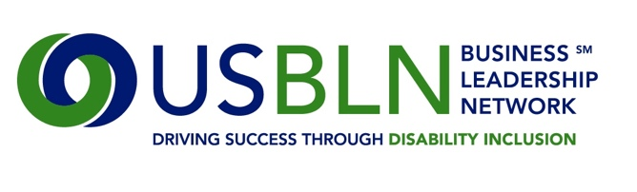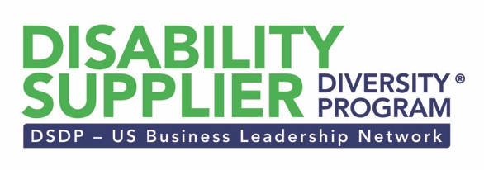

USBLN Supplier Mentoring Program

Program Description

USBLN’s Disability Supplier Diversity Program was launched in January 2010, responsible for providing a national third-party certification process for disability-owned business enterprises and service-disabled veteran owned business enterprises. In addition, the DSDP, working with USBLN corporate partners, uses a comprehensive approach to providing resources and developmental opportunities to its certified DOBEs and SDV-DOBEs.

As an essential component of these efforts, the USBLN Supplier Mentoring Program was created to further supplement the development of USBLN certified suppliers—building more viable suppliers to better position them for growth and inclusion in corporate and government supply chains.

The success of this mentoring initiative is dependent on engaged and collaborative individuals.
- USBLN partner representatives who are committed to the growth and development of disability suppliers (DOBEs and SDV-DOBEs) and who are willing to provide expertise and guidance to benefit these suppliers by dedicating time, resources, and knowledge
- USBLN certified suppliers who recognize the inherent need to improve their skills, business processes and management acumen in order to grow their businesses and are willing to dedicate themselves to participating in a structured mentoring approach for improvement
Benefits of the Supplier Mentoring Program
- Develop lasting relationships between corporate and government partners and certified suppliers
- Transfer of valuable knowledge and expertise
- Increase understanding of challenges confronting disability suppliers and procurement organizations
- Demonstration of commitment to disability supplier community
- Expansion of business networks

2017 Program Timeline and Commitment
- The program length is 12 months beginning in March 2017, consisting of set periodic meetings between mentors and mentees.
- The expectation is that mentoring pairs meet at least once monthly. The meetings may be conducted in-person, by phone, or via video conferencing.
- Participants are required to participate in a kick-off call and online orientation webinar in late March 2017, beginning their mentoring relationships immediately following.
- In addition, participants are required to provide monthly status reports to the USBLN program administrator to ensure continued successful outcomes.
- Mentees are also required to participate in follow-up check-ins after the program completion.
- A face-to-face meeting for mentors and mentees is planned for Monday, August 21, 2017 at the USBLN annual Conference in Orlando, FL.

Program Outline
- Complete program agreements
- Participate in program orientation
- Develop mentoring plan and establish agreed-upon success measures/goals
- Determine frequency of mentoring meetings
- Participate in individual or team mentoring
- Track and measure activities against set goals
- Provide USBLN program administrator with monthly report-outs

Successful Mentor Characteristics
- Highly enthusiastic and committed to the task of developing others, offering appropriate and sound guidance and feedback
- Open to spending time with a diverse entrepreneur who may or may not share a common background, values, or goals.
- Experience in establishing and maintaining professional networks and relationships, both online and offline
- Effective communicator with the ability to engage in reflective conversations.
- Fully committed and engaged

Successful Mentee Characteristics
- Enthusiastic and open to considering new ideas and approaches to business
- Highly motivated to complete a course of action once determined
- Strong work ethic
- Ability to balance priorities
- Effective communicator with the ability to engage in reflective conversations
- Fully committed and engaged

Primary Developmental Areas
- Accessing Capital
- Business Planning/Strategic Growth (Business Foundation – Mission, Vision, Business Plan)
- Business Process (Contract Management, Project Management, Operations)
- Human Resources Management (Selection, Development, Retention, Engagement)
- IT
- Leadership Development
- Marketing/Branding (Product Development, Innovation, Web & Social Media Presence)
- Sales/Bidding
- Strategic Collaboration (Networking, Partnerships, Joint Ventures, Alliances)
- Supply Chain Management (Sourcing, Audits, Safety, Sustainability, Distribution)

Participation in the USBLN Supplier Mentoring Program is solely for the purposes of education. Neither the mentor nor mentee should approach their participation in the program with the expectation of new or expanded business, contracts, or revenue. Furthermore, completion and submission of the USBLN Supplier Mentoring Program application is not a guarantee of selection and/or participation in the program.

