Event Goals
AdaptBRG@MassMutual.com
- Increase disability focused cultural competency by introducing MassMutual employees to new/different experiences and perspectives.
- Raise awareness around MassMutual’s disability inclusion efforts and inspire involvement.
- Inspire thoughtful reflection to spur ideas that will help MassMutual’s business.

Event Format
- 2hour event open to all emplooyees.
- Three guest speakers gave 18 minute talks followed by a reception that featured community organizations.
- Event was held at MassMutual’s home office and broadcast live via vBrick technology to all other MassMutual campuses and work from home employees. Meeting rooms were secured at larger locations so employees could gather and watch the video feed together.

Click here to view the See the Real Me Event Highlight Video.

Run of Show
Duration | Topic
15 min | Arrivals
2 min | Video: Olivia Wilde, How do you see me?
8 min | Opening remarks (Adapt Chair )
18 min | Speaker 1: Beth Donahue (Special Olympics athlete)
3 min | Video transition: Para Olympics
18 min | Speaker 2: Monica Donnelly (Mother of a son who is Autistic)
1 min | Video transition: Who I am
20 min | Speaker 3: Scott Rider (MassMutual Agent who has Parkinson’s Disease)
10 min | Closing remarks (Adapt Chairs)
35 min | Reception  - Refreshments  - Booths featuring representatives from Best Buddies, Special Olympics of MA, Easter Seals and MassMutual’s Special Care  - Adapt table with giveaways, member sign-up and volunteer opportunity sign-up  - Screen displaying event photos  - Screen displaying sli.do poll/Word Cloud

Other Event Elements
- Event reflection
  - Objective: To encourage thoughtful reflection of the event and action.
  - At end of the presentation portion asked audience members to reflect on this probing question: What is one action you will take as a result of today’s event?
  - Used Sli.do.com service so people could answer the question using their cell phones.
  - The poll responses were displayed real time in a word cloud during the reception.

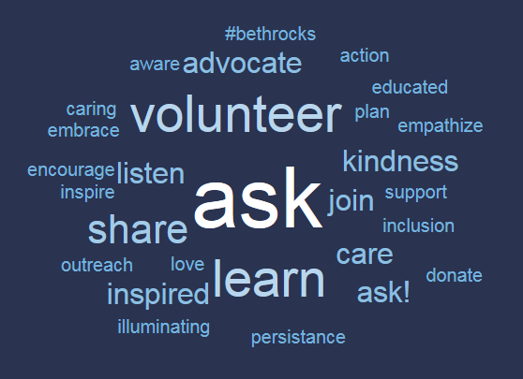

- See the real me selfies & photos
  - Attendees were asked to take pictures of themselves at the event and email them to a shared photo album (hosted by DropEvent.com)
  - A photo slide show was displayed at the reception and the pictures were moved to our BRG website after the event.

Event Marketing & Communications
- Company website news article
- Posters at each campus
- Sent invite to other BRGs to include in their monthly newsletters
- Message to senior leadership from the Diversity & Inclusion department
- Several email communications to the Adapt BRG membership list

Pre-Event Promotion
- Adapt BRG members set up a table at the exit of the cafeteria during peak hours (breakfast and lunch) a week before the event, a day before the event and the day of the event.
- Handed out candy and offered people a chance to enter a raffle for a free lunch ticket
- Set up event posters and handed out Adapt promo items
- Had ipads available so people could register for the event

Event Planning
- Planning began 4.5 months before the event
- The core team had 10 people. Some key roles were
  - Event lead
  - Communications lead
  - Speaker Coaches
  - Reception lead
  - Campus liaisons for other campuses
- The core team met weekly leading up to the event

Sample Project Plan
Category | Task
AV | Secure AV support for day of event
AV | Recording Logistics
AV | Pick music for event
AV | Upload presentations & videos for the presentation
AV | Arrange live captioning of event
Budget | Draft budget
Gifts | Purchase speaker gifts & wrapping
Lunch Reception | Decide on invite list for pre-event lunch
Lunch Reception | Send lunch invitations
Post Event Activities | Draft event survey
Post Event Activities | Send post event email to attendees
Pre-Event Prep | Check and respond to accommodation requests
Presentation- Other | Draft entrance slide show
Presentation- Other | Draft opening and closing remarks
Presentation- Slides | Compile PowerPoint Slides
Presentation- Video Transitions | Brainstorm video options
Presentation- Video Transitions | Pick 3 videos to show at event
Promotion | Save the Date to Adapt members
Promotion | Save the Date to Executive Leadership Team
Promotion | BRG Newsletter Promos
Promotion | Secure event photographer
Promotion | Create Campus Posters
Promotion | Design flyer for pre-event promos
Promotion | Company website Article
Promotion | Organize volunteers for handing out promo flyers
Reception Booths | Invite community organizations to participate
Refreshments | Order refreshments for each campus
Space | Secure dress rehearsal room
Space | Secure Event Rooms (all locations)
Space | Secure "green room" for speakers
Space | Confirm Set-Up/room Design
Speaker Prep | Create speaker prep plan
Speaker Prep | Schedule initial meeting with speaker
Speaker Prep | Initial Meeting with speakers
Speaker Prep | ID speaker AV needs
Speaker Prep | Speech draft #1
Speaker Prep | Final Speech draft
Speaker Prep | Send itinerary to speakers
Speaker Prep | Skype rehearsal
Speaker Prep | Finalized Speech & slides
Speaker Selection | Select Speakers
Speaker Selection | Vet speakers with D&I Liaison
Speaker Selection | Confirm speaker participation
Speaker Selection | Obtain speaker bios and pictures
Speaker Selection | Procurement Process - documentation
Travel | Book flights for speakers
Travel | Check accessibility and food/bev accommodations for speakers
Travel | Make ground transportation arrangements for speakers
Travel | Book hotel rooms for speakers
Travel | Provide advance notice to building security for speakers

