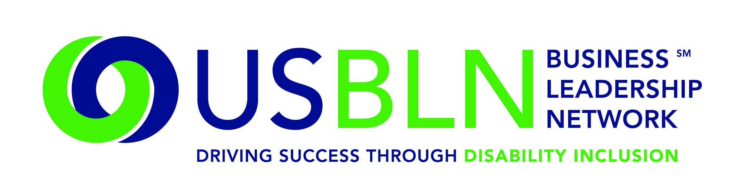

USBLN Hands out Top Leadership Awards at Annual Conference
Winners include Microsoft, AT&T, Wells Fargo, IBM and Capital One

For Immediate Release Contact: Shawna Berger
Oct. 2, 2015 Phone: (800) 706-2710
WASHINGTON, D.C. (Oct. 2, 2015) – The US Business Leadership Network® (USBLN®) presented top awards on Sept. 30 during the annual conference Leadership Awards in Austin, Texas. Recognition was given to six companies, an individual and an affiliate network for their outstanding commitment to and work in the disability inclusion community.

This year the USBLN expanded the Marketplace Innovator of the Year category to include two awards, one for a disability inclusive advertisement and one for product development. The eight 2015 USBLN Leadership Award categories and winners are:

- The John D. Kemp Leadership Award – Oswald “Oz” Mondejar, Senior Vice President, Mission and Advocacy for Partners Continuing Care, non-acute care services division of Partners HealthCare, Boston, Massachusetts
- Affiliate of the Year – Wyoming’s Uinta County Business Leadership Network
- Advocate of the Year-Supply Chain Inclusion – Capital One
- Supplier of the Year - Mark Ellson, Founder and CEO, Jemni, Inc.
- Top Corporation for Disability-Owned Businesses - IBM
- Marketplace Innovator of the Year, Disability Inclusive Advertisement – Wells Fargo & Company
- Marketplace Innovator of the Year, Product Development – AT&T
- Employer of the Year - Microsoft

One of the cornerstones of the USBLN is the supplier diversity program. Part of the success of the program is that the USBLN is the leading third-party certifier of disability-owned firms, including service-disabled veteran-owned businesses (SDVOBs). The Advocate of the Year – Supply Chain Inclusion award recognizes the individual advocate and/or procurement champion, who has provided exceptional support in the development of USBLN-certified Disability-Owned Business Enterprises® (DOBEs) and the USBLN Disability Supplier Diversity Program® (DSDP). Capital One has demonstrated outstanding commitment to the utilization and growth of disability-owned businesses.

“At Capital One we understand the value that a diverse supplier base provides to our company, enabling us to bring together diverse perspectives, backgrounds and experiences that reflect the customers and communities we serve,” said Kimberlee Sours, Supplier Diversity, Capital One. “Through active engagement with groups like USBLN, we work to continually improve our Supplier Diversity programs and better serve the wide-ranging needs of our customers and communities.”

The Top Corporation for Disability-Owned Businesses award was given to IBM because they have demonstrated outstanding inclusion of USBLN-certified disability-owned businesses, including businesses owned by service disabled veterans. IBM has a proven commitment to disability business inclusion in their supply chain processes and corporate supplier diversity programs.

“IBM has a long history of diversity and it remains a foundation of our business,” said Dan Carrell, Vice President, Operations and Client Services Procurement, IBM. “That commitment extends to IBM's suppliers, where we look for those who can provide value regardless of race, gender or disability.”
Wells Fargo & Company took home the inaugural Marketplace Innovator Award of the Year, Disability Inclusive Advertisement for its memorable commercial representing two emerging diversity market segments engaged in a common human goal – to have a family. The commercial reflects the company’s leadership in creating a marketing campaign that embraces the business value of a diverse market, including the disability market.

“I was extremely proud to accept this award on behalf of Wells Fargo and our 265,000 team members in the U.S. and around the world,” said Kathy Martinez, Wells Fargo People with Disabilities Market Segment and Strategy Manager. “Much like the USBLN, diversity and inclusion is foundational to who we are as a company. Our support of the disability and the LGBT communities aligns with our broader commitment to diversity –to serve diverse customers, to hire, develop and retain diverse team members and to encourage team members to value and respect each other for their differences.”

The Marketplace Innovator of the Year, Product Development award was given to AT&T for their development work on Real Time Text (RTT) that allows both users to send and receive text and voice at the same time. The ground-breaking technology that follows universal design principles will be available commercially in 2017. It will greatly enhance opportunities for individuals with disabilities to advance in their careers and to enrich their personal lives.

“Real Time Text has been a great collaboration between individuals with different skills and outlooks from across AT&T – and even outside the company,” said Aaron Bangor, PH.D. CHFP, AT&T Corporate Accessibility Technology Office. “Committing to disability inclusion throughout the design process draws out our creativity and ingenuity and helps us to deliver better products and services for our customers – and for society in general, and RTT is one of the resulting technologies.”

The 2015 USBLN Employer of the Year Award was awarded to Microsoft. Microsoft is internationally recognized for exemplary policies, strategies and initiatives that have resulted in measurable results in the areas of disability inclusiveness in the workplace, marketplace and supply chain. The disability inclusion work Microsoft is doing is significant to the disability inclusion community and truly moving the needle in this space.

“We are so humbled and inspired by this recognition. Our mission at Microsoft is to empower every person and organization on the planet to achieve more and our journey with disability inclusion embodies that mission. We’re proud of programs like the Autism Hiring Pilot, and Disability Answer Desk, as well as our partnership with organizations like Special Olympics. We look forward to continuing our journey to empower people of all abilities,” said Mary Ellen Smith, corporate vice president, Microsoft Operations.

Additional highlights include the John D. Kemp Leadership Award, which is presented to an individual who has developed or influenced the development of significant company disability employment programs and services that result in measurable, tangible and positive outcomes, dramatically improving disability employment opportunities.

Oswald “Oz” Mondejar has dedicated his life to unlocking opportunities for people with disabilities, and to overcoming societal barriers based upon ethnicity, class, gender, sexual orientation and health status. “Oz” Mondejar, Senior Vice President, Mission and Advocacy, Partners Continuing Care, Inc. (“PCC”), the non-acute care services division of Partners HealthCare. Oz works at the intersection of policy, advocacy and media, defining PCC’s core values and leveraging the organization’s resources in order to maximize positive social impact - locally, nationally and internationally. He is responsible for mission integration and administrative operations across three divisions: Human Resources, Marketing Communications, and Community Relations including Adaptive Sports.

Prior to joining Partners HealthCare in 2001, Oz led the New England Region recruitment program for the Social Security Administration and worked as a human resources executive in a number of different industries including manufacturing, hospitality and finance.

“For me to receive the John D Kemp award is really one of the most meaningful I could ever ask for,” said Oz Mondejar, Senior Vice President, Mission and Advocacy, Partners Continuing Care, Inc. “The USBLN is really the bridge between business and an untapped talent pool. My focus throughout my career has been to work with others in both the public and private sectors to break down those real and perceived barriers to see that hiring persons with disabilities is more than a ‘good thing to do’ it truly is good business. I'm so proud to accept this from an organization that understands that."
Also, 4 Wheel City, an entertainment organization started by Namel “Tapwaterz” Norris and Ricardo “Rickfire” Velasquez who are two talented hip-hop artists, motivational speakers and are wheelchair users due to gun violence provided entertainment. Their mission is to use hip-hop music and culture to create more opportunities for people with disabilities and inspire people not to give up in life.

As a surprise to the award winners, they each received an airline voucher from conference airline partner, Southwest Airlines to fly anywhere in the domestic United States.

“We are thrilled to honor these amazing companies and individuals for the work they are doing in the disability inclusion space,” said Jill Houghton, executive director, USBLN. “We are grateful for their partnership and it’s a fantastic way to kick off Disability Employment Awareness Month.”

The sold out conference concluded Oct. 1.

About the US Business Leadership Network (USBLN)
The US Business Leadership Network (USBLN) is a national non-profit that helps business drive performance by leveraging disability inclusion in the workplace, supply chain, and marketplace. The USBLN serves as the collective voice of nearly 50 Business Leadership Network affiliates across the United States, representing over 5,000 businesses. Additionally, the USBLN Disability Supplier Diversity Program® (DSDP) is the nation’s leading third party certification program for disability-owned businesses, including businesses owned by service-disabled veterans.

###

