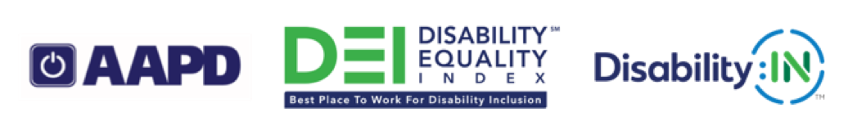
2019 Disability Equality Index® (DEI®) Best Places to Work™
The American Association of People with Disabilities and Disability:IN™ are honored to recognize the following companies that scored an 80 or above on the 2019 DEI. The DEI was completed by 180 companies in 2019.
Note: The companies are listed in alphabetical order, by the company name as provided to AAPD and Disability:IN.
Companies that scored 100%
3M | Accenture | Aetna | Ameren Corporation | American Airlines
American Water | Anthem, Inc. | Aramark | AT&T | BAE Systems, Inc.
Bank of America | Best Buy Co., Inc. | Biogen | Blue Cross Blue Shield of Michigan | BMO Harris Bank
Boehringer Ingelheim Pharmaceuticals, Inc. | Booz Allen Hamilton | Boston Scientific | Bristol-Myers Squibb Company | Brown-Forman Corporation
Capital One Financial Corporation | Cargill, Inc. | Centene Corporation | Chevron Corporation | Children's Hospital of Philadelphia
Cigna | Cisco | Comcast NBCUniversal | Corning | CSX Transportation, Inc.
CVS Health | Dell Technologies | Deloitte | Delta Air Lines, Inc. | Dow Inc.
DTE Energy | DuPont | DXC Technology | Entergy Corporation | Express Scripts
EY | Facebook, Inc. | Fidelity Investments | Florida Blue | Ford Motor Company
Freddie Mac | General Motors | GlaxoSmithKline plc | Goldman Sachs & Co. | Google LLC
Health Care Service Corporation | Hewlett Packard Enterprise | Highmark Health | HP Inc. | Huntington Bank
Intel Corporation | JPMorgan Chase & Co. | Kaiser Permanente | KPMG LLP | L'Oreal USA
Lincoln Financial Group | LinkedIn | Lockheed Martin | M&T Bank | ManpowerGroup
Mastercard | McKesson Corporation | Medtronic plc | Merck | MetLife Inc.
Microsoft | Nielsen | Northern Trust | Northrop Grumman | Northwestern Mutual
Old National Bank | Pacific Gas and Electric Company | PNC Financial Services Group, Inc. | PPL Corporation | Procter & Gamble
Prudential Financial | PwC | Qualcomm | Raytheon Company | Salesforce
SAP America, Inc. | Southern California Edison, an Edison International Company | Southern Company | Spaulding Rehabilitation Network | Sprint Corporation
Starbucks Coffee Company | State Street Corporation | Synchrony | T-Mobile | TD Bank N.A.
The Boeing Company | The Hartford | The Travelers Companies, Inc. | The Walt Disney Company | Thermo Fisher Scientific
Thomson Reuters | Tufts Health Plan | U.S. Bank | Unilever USA | United Airlines
Verizon | Voya Financial | Walgreens | Walmart Inc. | WellCare Health Plans, Inc.
Whirlpool Corporation

Companies that scored 90%
Amazon | American Electric Power, Inc. | AMC Entertainment, Inc. | AXA Equitable Life | BD (Becton, Dickinson and Company)
Blue Cross and Blue Shield of Massachusetts, Inc. | Blue Shield of California | BNY Mellon | Citrix | Colgate-Palmolive
First Data | JLL | Johnson & Johnson | MassMutual | Meijer
MITRE | Motorola Solutions | OppenheimerFunds, Inc. | Quest Diagnostics | Royal Caribbean Cruises Ltd.
S&P Global | Sanofi | Sodexo Inc. | Steptoe & Johnson LLP | TEKsystems
Uber Technologies Inc. | UPS | Viasat | W.W. Grainger, Inc.

Companies that scored 80%
Bayer | Choice Hotels | CUNA Mutual Group | Duke Energy Corporation | Franklin Templeton
Grant Thornton LLP | Land O’Lakes, Inc. | Lowe’s Companies, Inc. | Norfolk Southern Corporation | Rush University Medical Center
Southwest Airlines Company | The Coca-Cola Company | Ultimate Software | United Technologies Corporation | Unum Group
USAA

To learn more about the DEI, visit: https://www.disabilityequalityindex.org
© Copyright 2019. American Association of People with Disabilities (AAPD). Disability:IN™. All rights reserved.

